caBIG Clinical Connector C3D
Version No: 2.2
Last Modified: 06/25/2010
Author : Patrick Conrad
Team : caBIG Clinical Connector C3D
Client : National Cancer Institute - Center for Bioinformatics,
National Institutes of Health,
US Department of Health and Human Services

DOCUMENT CHANGE HISTORY
Version Number | Date | Contributor | Description
1.0 | 06/25/2010 | Patrick Conrad | Initial Draft
1.1 | 07/01/2010 | Patrick Conrad | Updates as a result of review meeting with QA.

TABLE OF CONTENTS
1 Background/Summary 4
2 Introduction 5
2.1 Document Overview 5
2.2 SCOPE 5
2.2.1 The caBIG Clinical Connector C3D Service 5
2.3 Vision 6
2.3.1 System Component Identification 6
2.4 Related documents 7
2.5 Application System Diagram 8
2.6 Release Overview 8
2.7 Definitions 9
3 caBIG Clinical Connector C3D requirements 10
3.1 Constraints 10
3.2 Qualification Provision 11
3.3 Assumptions 11
3.4 Dependencies 11
3.4.1 Security 12
3.5 Environment 12
4 Application Functional Requirements 13
4.1 caBIG Clinical Connector C3Dsolution Requirements 13
4.1.1 caBIG Clinical Connector C3D Use Cases 13
4.1.2 caBIG Clinical Connector C3D Components 15
Glossary 23

Background/Summary
The overall goal of this project is to build a grid service as an interface to operations that support the clinical trials workspace of C3D. Compliance with the caBIG principles of open source, open development, open access, and federation will be used as the caBIG program is the primary sponsor of this project.
(https://cabig.nci.nih.gov/guidelines_documentation/caBIGCompatGuideRev2_final.pdf)
The key roles in the project are defined in Table 1.
Table 1 Key caBIG Clinical Conector C3D Project Roles
Role | Name | Comments
Project Sponsor | caBIG
Reviewer | caBIG Architecture Workspace | Will review and provide guidance of architecture artifacts
Reviewer | CCTS Architecture Team | Will provide requirements
User | NCICB | Responsible for hosting the hub
Developer | Ekagra Software Technologies | Joint Development Team

The caBIG Clinical Connector C3D consists of multiple distributed components. The components related to the caBIG Clinical Connector C3D and their respective locations where they will be hosted are provided in Table 2.
Table 2 caBIG Clinical Connector C3DComponents
Component | Hosting Site | Comments
caBIG Clinical Connector C3D Service | NCICB | The primary service
caBIG Clinical Connector C3D DCAPI adapter | NCICB | The interface between the service and the COTS C3D Data Capture application interface modules.
caBIG Clinical Connector C3D HotLink provider | NCICB | The Oracle forms based application used to support HotLink execution.

Introduction

Document Overview
This Software Requirements Specification (SRS) document captures the software requirements for the caBIG Clinical Connector C3D. The overall goal of this project is to build a grid services as an interface to operations that support the clinical trials workspace of C3D.

SCOPE
The caBIG Clinical Connector C3D project involves both technical and non-technical efforts that are divided amongst the groups defined in Section 1. The caBIG Clinical Connector C3D service is defined as the software component that is primarily responsible for receiving service requests and applying that request to the C3D CDMS.
The scope of caBIG Clinical Connector C3D version 2.2 effort includes continued support for the CCTS Suite. Additionally, it provides Grid services that currently do not exist within tht eC3D framework.
caBIG Clinical Connector C3D provides the following functionality to the community. Specifically:
- The ability to register patients on C3D Studies
- The ability to accept and load patient laboratory test results to C3D Study CRFs
- The ability to retrieve Study specific metadata
- The ability to retrieve Study data based on study metadata
- Compliance with the NCI CBIIT Build and Deployment Automation process

The caBIG Clinical Connector C3D Service
The caBIG Clinical Connector C3D Service is defined as the software component that is primarily responsible for receiving input and passing it along to C3D. The service will also authenticate Grid users requesting the service as well as check Grid user authorization.
For this effort the caBIG Clinical Connector C3D service will reside on the NCICB servers. The caBIG Clinical Connector C3D service will be responsible for implementing the following integration scenarios of the CCTS Suite:
- Receiving patient laboratory test result data and loading the data to the designated patient on the designated Study to the appropriate case report form as defined for the designated study in C3D.
- Receiving patient study registration requests and enrolling the patient to the designated Study. As part of the registration process, the service will also load patient data elements to the appropriate Study case report form (CRF) within the designated study in C3D. The process of loading data into C3D will leverage the existing COTS interfaces known as, DCAPI (Data Capture Application Interface).
- Each service will implement security in the form of both authentication and authorization. Only authenticated Grid users will be allowed to call upon the Clinical Connector C3D Services. Authorization for Grid users will also be confirmed. To implement this security model, CBIIT Common Security Module (CSM) will be used.
Outside of the direct scope of the CCTS Suite, the caBIG Clinical Connector C3D service will also be responsible for implementing the following non-integration scenarios:
- Retrieving Study specific design metadata.
- Retrieving Study data for specific design metadata elements.
As part of the CCTS Suite, caBIG Clinical Connector C3D will be responsible for implementing any additional integration scenarios.
The caBIG Clinical Connector C3D software should comply with the NCI CBIITs Build and Deployment Automation infrastructure.

Vision
Clinical laboratory systems in cancer centers often (but not always) have an interface that supplies laboratory data in the form of HL7v2.x messages. It is also possible that some clinical laboratory systems can only supply data in comma delimited or other file formats, or that the local healthcare system’s information services organization chooses to provide information in such a manner. Various clinical trials management systems likewise may accept data in multiple formats. The program’s interest is in providing infrastructure to support implementation of integration scenarios in the clinical trial space. Currently, cancer centers desiring integration among their clinical trial related software products are faced with an expensive project to custom-build an interface between the two systems. Owing to the heterogeneous nature of clinical trial software systems, it is not expected that the local integration efforts to provide the appropriate message syntax at cancer centers can be reduced to zero, but minimizing local development work is highly desirable.
This project will focus on the development of an open-source, caBIG compatible solution to support the exchange of laboratory data collected during a clinical trial. The resulting solution must be stand alone and Silver level compatible.

System Component Identification
The entire solution, including the items not addressed in this document will be identified as the “caBIG Integration Hub”. The following sub-sections identify the components that are addressed in this document.

Software
Table 3 Project Software
Title | Abbreviation | Release #
caBIG Clinical Connector C3DESB | ESB | 2.1
caBIG Clinical Connector C3Dinbound Request Processor Service | caBIG Clinical Connector C3Drequest Processor | 2.1
caBIG Clinical Connector C3Dgeneric Consumer Service | caBIG Clinical Connector C3Dconsumer | 2.1
caBIG Clinical Connector C3DopenClinica Plugin | OpenClinica Plugin | 2.1
OpenClinica webSSO Client | OpenClinica webSSO Client | 2.1

Documentation
Table 4 Project Documentation
Title | Abbreviation | Release #
Requirements and Specification Document | N/A | 2.1
Project Management Plan | N/A | 2.1
Project Schedule | N/A | 2.1
Use Cases | N/A | 2.1
Technical Architecture Guide | N/A | 2.1
Design Document | N/A | 2.1
Domain Model | N/A | 2.1
Interface Specification | N/A | 2.1
Test Plan | N/A | 2.1
Installation Guide | Install Guide | 2.1
Administrative Guide | Admin Guide | 2.1

It is important to note that providing documentation for any of the COTS or Open Source products utilized in caBIG Clinical Connector C3Dis not in the scope of this release. For obtaining documentation on these products, it is suggested that users or developers go to the website hosting the particular product they are interested in to retrieve the documentation. Links to the documents above are provided in the following section.

Related documents
Table 5 Related Documents
Document Name | Location
caBIG Clinical Connector C3Duse Case Documents | https://ncisvn.nci.nih.gov/svn/cabigintegrationhub/trunk/docs/Requirements/
caBIG Clinical Connector C3Ddesign Document | https://ncisvn.nci.nih.gov/svn/cabigintegrationhub/trunk/docs/Design/
caBIG Clinical Connector C3Dtechnical Architecture Guide | https://ncisvn.nci.nih.gov/svn/cabigintegrationhub/trunk/docs/Design/
caBIG Clinical Connector C3Dinstallation Guide | https://ncisvn.nci.nih.gov/svn/cabigintegrationhub/trunk/docs/installation/
caBIG Clinical Connector C3Dinterface Specification | https://ncisvn.nci.nih.gov/svn/cabigintegrationhub/trunk/docs/Interface/

Application System Diagram
The diagram below depicts the caBIG Clinical Connector C3D and the external systems that it will interact with.
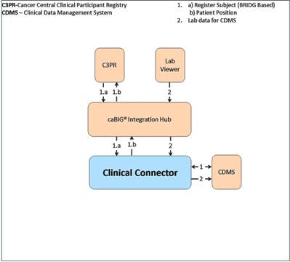
Figure 1 caBIG Clinical Connector C3D System Diagram

Release Overview
Table 6 Project Release Information
Release | Date Released | Version comments
1.0 | 2/14/2008 | Will be a part of CCTS 1.0 release
1.5 | 10/30/2008 | Will be a part of CCTS 1.5 release
2.0 | 09/30/2009 | Will be a part of the CCTS 2.0 release
2.1 | 03/31/2010 | Will be a part of the CCTS 2.1 release
2.2 | 08/01/2010 | Will be a part of the CCTS 2.1 release

Definitions
Developers and Adopters are expected to clearly understand the definitions and agree upon the ranking of the definitions used with any given requirement.
MUST – This word means that the definition is an absolute requirement of the specification.
MUST NOT – This phrase means that the definition is an absolute prohibition of the specification.
WILL – This word means that the definition is an absolute future requirement of the specification.
WILL NOT – This phrase mean that the definition is an absolute future prohibition of the specification.
SHOULD – This word means that there may exist valid reasons in particular circumstances to ignore a particular item, but the full implications must be understood and carefully weighed before choosing a different course.
SHOULD NOT – This phrase means that there may exist valid reasons in particular circumstances when the particular behavior is acceptable or even useful, but the full implications should be understood and the case carefully weighed before implementing any behavior described with this label.
MAY – This word means that a requirement is truly optional. The developer may choose to include the item based on the needs of their design.

caBIG Clinical Connector C3D requirements
There user/system requirements are derived from original Laboratory Information Clinical Connector C3D Statement of Work, enhancement requirements for CTMSi, the SOW for Phase III of caBIG Integration Hub, the kick off meeting and project plan for the Phase IV of caBIG Clinical Connector C3Das well as requirement gathering meetings with project stakeholders. The list of stakeholders consists of:
- CTMS Study Conduct SIG
- CCTS architecture team
- NCICB Product Management
Additional requirements will be gathered during the review period of the draft of this document as well as during the initial design phase of the various caBIG Clinical Connector C3Dcomponents.
The requirements can be grouped into two major categories: (1) Software and (2) Documentation. The Software category includes the requirements for each of the components being developed by the caBIG Clinical Connector C3Dtechnical team that comprise the end to end technical solution. The Documentation category includes a description of the various documentation artifacts that are expected to be produced by the caBIG Clinical Connector C3Dteam during the version 2.1 release.

Constraints
The constraints that apply to the caBIG Clinical Connector C3D software engineering options are provided below:
- All software components utilized in this solution must be open source and freely distributable.
- The software components utilized in this solution should adhere to the existing technology stack of the environments they will be deployed in.
- The solution must meet the HIPAA privacy standards.
- The solution must adhere to technical and operational principles of the caBIG program.
- The solution must make use of the Oracle Clinical DCAPI functions when applying data to the internal CRF of C3D Studies.

Qualification Provision
This section defines a set of qualification methods and shall specify for each of the requirements defined and the method(s) to be used to ensure that the requirement has been met.
Table 7 Qualification Requirements
Qualification Method | Description | Requirements
Demonstration | The operation of the system or component that relies on observable functional operation not requiring the use of instrumentation, special test equipment, or subsequent analysis.
Test | The operation of the system or component using instrumentation or other special test equipment to collect data for later analysis.
Analysis | The processing of accumulated data obtained from other qualification methods. Examples are reduction, interpretation, or extrapolation of test results.
Inspection | The visual examination of code, documentation, etc.

Assumptions
The assumptions of the caBIG Clinical Connector C3D and its related software components are:
- The NCICB hosted components will be deployed in the shared production NCICB environment.
- The project components will adhere as closely as possible to the published NCICB Future Technology Stack
- The caCORE and caBIG products utilized in this solution are expected to perform their proposed functionality. If there are any product defects, they will be fixed by the respective product team and not the caBIG Clinical Connector C3D development team.
- If the appropriate versions of the proposed products that are expected to be used in this solution are not available, a work around must be implemented by the caBIG Clinical Connector C3D team, however, the caBIG Clinical Connector C3D team will not write replacements for those products.

Dependencies
The dependencies of the caBIG Clinical Connector C3D and its related software components are described below:
- The build and deployment of the caBIG Clinical Connector C3D project will use the templates from the NCI CBIITs Build Deployment Automation project.

Security
The Credential Delegation Service and other caGrid authentication infrastructure will be utilized for the CCTS project and caBIG Clinical Connector C3D will integrate for user level authentication and authorization.

Environment
All caBIG projects must be platform and database-independent applications. In the case of caBIG Clinical Connector C3D, however, the dependence on the Oracle base C3D means that it must be implemented on the same operating system and database required by C3D.. Table 8 below details the environment to be used for testing caBIG Clinical Connector C3D.
Table 8 System Environment
Operating system for Service | Microsoft Windows Server 2003/Standard Edition/SP 2
Database | Oracle9i Enterprise Edition Release 9.2
Browser | Internet Explorer 6
Java | 1.5.0_10 SDK
Container | Tomcat 5.5.27
Ant | 1.7.0
caGrid | 1.3

Application Functional Requirements

caBIG Clinical Connector C3Dsolution Requirements
The following sections describe the requirements for the caBIG Clinical Connector C3D components.

caBIG Clinical Connector C3D Use Cases
caBIG Clinical Connector C3Duse cases are described in detail in separate use case documents. The latest versions of these documents can be found here:
https://ncisvn.nci.nih.gov/svn/cabigintegrationhub/trunk/docs/Requirements/
The diagram below depicts the use cases and actors for the caBIG Integration Hub. The main client interactions with the caBIG Clinical Connector C3Dinclude processing request asynchronously, response retrieval and process request synchronously. The other use cases may be included in these use cases based on the needs of the integration scenario.
The use case diagram below is available caBIG Clinical Connector C3Ddesign EA project. The latest version of this EA project file can be found here:
https://ncisvn.nci.nih.gov/svn/cabigintegrationhub/trunk/docs/Design/caBIG%20Integration%20Hub%20Design.eap

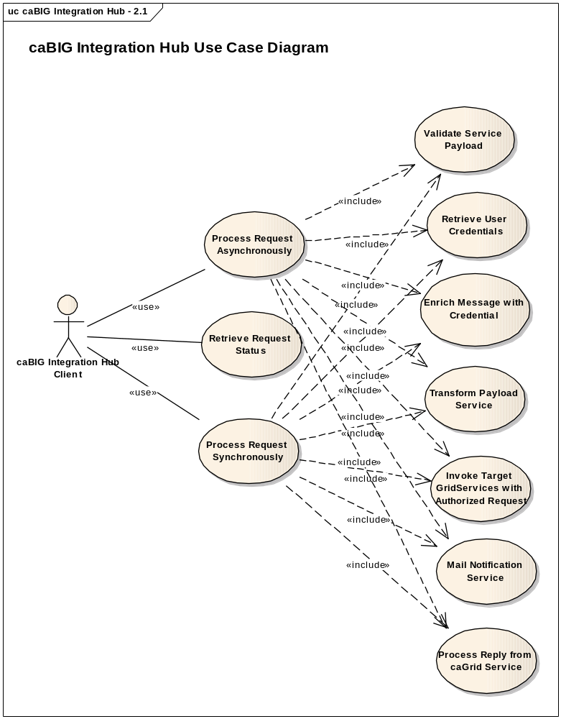
Figure 2 caBIG Clinical Connector C3Duse cases
The following diagram illustrates the caBIG Clinical Connector C3Duse cases for routing configuration. These use cases outline the hub functionality required for configuring new integration scenarios and updating existing integration scenarios to add or remove services.
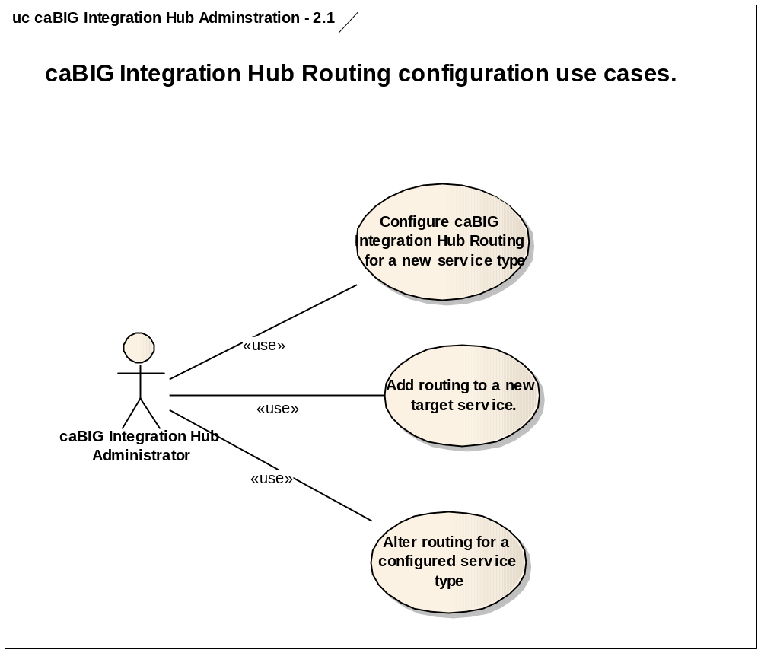
Figure 3 caBIG Clinical Connector C3Dadministration use cases

caBIG Clinical Connector C3D Components
This section describes the requirements for the caBIG Clinical Connector C3Dcomponent of the caBIG Clinical Connector C3Dsolution. The requirements have been documented in Table 9.
Table 9 caBIG Clinical Connector C3Dcomponent Requirements
ID | Type | SUITE  Test | Requirement Details | Release | Use Case | Service
 | Functional | N | The Clinical Connector shall send Client an error message when C3D not available | 1.5 |  | ALL
 | Functional | Y | The Clinical Connector shall be capable of registering a subject in C3D on the specified study and site. | 1.0 |  | Register Subject
 | Security | Y | The Clinical Connector must use a C3D Superuser ID for registering a subject in C3D. | 1.0 |  | Register Subject
 | Functional | Y | The Clinical Connector shall return Success when valid Patient Position is acquired, even if it fails to load associated C3D CRF Study Questions subsequently. | 1.0 |  | Register Subject
 | Functional | Y | After successful registration of a subject in C3D, the Clinical Connector shall return the C3D Study Patient Position to the client. | 1.0 |  | Register Subject
 | Functional | Y | The Clinical Connector shall send Client an error message when C3D Patient Positions are not available for the specified study. | 1.0 |  | Register Subject
 | Functional | Y | The Clinical Connector shall update Birth Date in the Patient Position table of C3D based upon user control settings of the Register Subject service. | 1.0 |  | Register Subject
 | Functional | Y | The Clinical Connector shall update Gender in the Patient Position table of C3D based upon user control settings of the Register Subject service. | 1.0 |  | Register Subject
 | Functional | Y | The Clinical Connector shall update First Name in the Patient Position table of C3D based upon user control settings of the Register Subject service. | 1.0  Changed in 2.2 |  | Register Subject
 | Functional | Y | The Clinical Connector shall update Last Name in the Patient Position table of C3D based upon user control settings of the Register Subject service. | 1.0  Changed in 2.2 |  | Register Subject
 | Functional | Y | The Clinical Connector shall use Patient First Name and Last Name in the register subject message to obtain Patient Initials. | 1.0 |  | Register Subject
 | Functional | Y | The Clinical Connector shall update Patient Initials in the Patient Position table of C3D based upon user control settings of the Register Subject service. | 1.0 |  | Register Subject
 | Functional | Y | The Clinical Connector shall update Enrollment Date in the Patient Position table of C3D based upon user control settings of the Register Subject service. | 1.0 |  | Register Subject
 | Functional | Y | The Clinical Connector shall place Patient Id value (MRN) from register subject message into the associated C3D Study Question.  a. The associated C3D Study Question is identified by CDE ID and Version, for the Study.  b. If there is no C3D Study Question specified for the Study, the default Study Question for MRN shall be used. | 1.0 |  | Register Subject
 | Functional | Y | The Clinical Connector shall place NCI Institution Code value from register subject message into the associated C3D Study Question.  a. The associated C3D Study Question is identified by CDE ID and Version, for the Study.  b. If there is no C3D Study Question specified for the Study, the default Study Question for NCI Institution Code shall be used. | 1.0 |  | Register Subject
 | Functional | Y | When loading values to C3D Study CRF Questions received in the Subject Registration message, the Clinical Connector shall use CDE Ids for identifying the corresponding C3D Study CRF Questions. | 1.0 |  | Register Subject
 | Functional | Y | The Clinical Connector must use C3D Data Capture APIs (DCAPI) for loading values to C3D Study CRF Questions. | 1.0 |  | Register Subject
 | Functional | Y | The Clinical Connector shall send Client an error message when multiple locations for the specified CDE ID for loading into C3D Study CRF Questions are found within the specified C3D Study. | 1.0 |  | Register Subject
 | Functional | Y | The Clinical Connector shall send Client an error message when the specified Study is not a valid C3D Study. | 1.5 |  | Register Subject
 | Functional | Y | The Clinical Connector shall send Client an error message when the Specified CDE Id for loading is not found in the design of the specified C3D Study. | 2.1 |  | Register Subject
 | Security | Y | The Clinical Connector shall allow only Authenticated Grid Ids to call the register subject service | 2.1 |  | Register Subject
 | Security | Y | The Clinical Connector shall send client an error message then the Grid Id calling the register subject service cannot be authenticated. | 2.1 |  | Register Subject
 | Security | Y | The Clinical Connector shall allow Only Authorized Gird Ids via CSM to invoke the Register Subject service | 2.1  Changed in 2.2 |  | Register Subject
 | Security | Y | The Clinical Connector shall send Client an error message when the user is not authorized to invoke the Register Subject service. | 2.1 |  | Register Subject
 | Security | Y | The Clinical Connector shall allow Only Users Authorized via CSM to invoke the Register Subject service. User must have “registrar” role and the role must have the CCC3D_ENROLLPATIENT_SERVICE privilege within CSM for a user to be allowed to execute the service. | 2.2  Changed from 2.1 |  | Register Subject
 | Functional | Y | The Clinical Connector shall NOT update First Name in the Patient Position table of C3D regardless of user control settings of the Register Subject service. | 2.2 |  | Register Subject
 | Functional | Y | The Clinical Connector shall NOT update Last Name in the Patient Position table of C3D regardless of user control settings of the Register Subject service. | 2.2 |  | Register Subject
 | Functional | Y | The Clinical Connector shall place Patient Birth Date value from register subject message into the associated C3D Study Question.  a. The associated C3D Study Question is identified by CDE ID and Version, for the Study.  b. If there is no C3D Study Question specified for the Study, the default Study Question for Patient Birth Date shall be used. | 2.2 |  | Register Subject
 | Functional | Y | The Clinical Connector shall place Patient Gender value from register subject message into the associated C3D Study Question.  a. The associated C3D Study Question is identified by CDE ID and Version, for the Study.  b. If there is no C3D Study Question specified for the Study, the default Study Question for Patient Gender shall be used. | 2.2 |  | Register Subject
 | Functional | Y | The Clinical Connector shall place Patient Informed Consent Signed Date value from register subject message into the associated C3D Study Question.  a. The associated C3D Study Question is identified by CDE ID and Version, for the Study.  b. If there is no C3D Study Question specified for the Study, the default Study Question for Patient Informed Consent Signed Date shall be used. | 2.2 |  | Register Subject
 | Functional | Y | The Clinical Connector shall place Patient Initials from register subject message into the associated C3D Study Question.  a. The associated C3D Study Question is identified by CDE ID and Version, for the Study.  b. If there is no C3D Study Question specified for the Study, the default Study Question for Patient Initials shall be used. | 2.2 |  | Register Subject
 | Functional | Y | The Clinical Connector shall place Registration Date value from register subject message into the associated C3D Study Question.  a. The associated C3D Study Question is identified by CDE ID and Version, for the Study.  b. If there is no C3D Study Question specified for the Study, the default Study Question for Registration Date shall be used. | 2.2 |  | Register Subject
 | Functional | Y | The Clinical Connector shall use the system date value for Registration Date value if the Registration Date value from register subject message is blank or null. | 2.2 |  | Register Subject
 | Functional | Y | The Clinical Connector shall place Patient Informed Consent Signed Version value from register subject message into the associated C3D Study Question.  a. The associated C3D Study Question is identified by CDE ID and Version, for the Study.  b. If there is no C3D Study Question specified for the Study, the default Study Question for Patient Informed Consent Signed Version shall be used. | FUTURE |  | Register Subject
 | Functional | Y | The Clinical Connector shall accept Laboratory Data for loading into C3D | 1.0 |  | Load Labs
 | Functional | Y | The Clinical Connector shall use the C3D Lab Loader Utility for loading Lab Test Data into C3D Study Lab CRFs. | 1.0 |  | Load Labs
 | Security | Y | The Clinical Connector must use an identified C3D Superuser for C3D data updates. | 1.0 |  | Load Labs
 | Functional | Y | The Clinical Connector shall send Client an error message when C3D not available. | 2.1 |  | Load Labs
 | Security | Y | The Clinical Connector shall allow only Authenticated Grid Ids to call the Load Lab service. | 2.1 |  | Load Labs
 | Security | Y | The Clinical Connector shall send Client an error message when user is not authenticated. | 2.1 |  | Load Labs
 | Security | Y | The Clinical Connector shall allow only Users Authorized via CSM to invoke the Load Lab service | 2.1  Changed in 2.2 |  | Load Labs
 | Security | Y | The Clinical Connector shall send Client an error message when user is not authorized for service. | 2.1 |  | Load Labs
 | Functional | Y | The Clinical Connector shall alert identified support personnel via e-mail when errors occur during processing of Lab data loading via the Load Labs service. | 2.1 |  | Load Labs
 | Security | Y | The Clinical Connector shall allow only Users Authorized via CSM to invoke the Load Lab service. User must have “lab_data_user” role and the role must have the CCC3D_LOADLABS_SERVICE privilege within CSM for a user to be allowed to execute the service. | 2.2  Changed from 2.1 |  | Load Labs
 | Functional | N | The Clinical Connector shall accept requests to retrieve Study Data for specified CDE/Version for specified Study. | 1.5 |  | Get Study CDE Data
 | Functional |  | The Clinical Connector shall send Client an error message when Study is not valid | 1.5 |  | Get Study CDE Data
 | Functional |  | The Clinical Connector shall send Client an error message when the specified CDE Id/Version is not found in the Specified C3D Study. | 1.5 |  | Get Study CDE Data
 | Functional | N | The Clinical Connector shall query C3D Study Design and C3D Global Library to acquire each CDE Instance within the specified study. | 1.5 |  | Get Study CDE Data
 | Functional | N | The Clinical Connector shall acquire associated study specific context data related to each CDE Id retrieved from the C3D Study design. | 1.5 |  | Get Study CDE Data
 | Functional | N | The Clinical Connector shall return CDE Id and Context data along with patient data to the client for the specified study and CDE Id / Version | 1.5 |  | Get Study CDE Data
 | Security | N | The Clinical Connector shall allow only Authenticated Grid Ids to call the Get Study CDE Data service. | 2.1  Changed in 2.2 |  | Get Study CDE Data
 | Security | N | The Clinical Connector shall send client and error message when the Grid Id cannot be authenticated. | 2.1 |  | Get Study CDE Data
 | Security |  | The Clinical Connector shall send Client an error message when user is not authorized for study. | 2.1 |  | Get Study CDE Data
 | Security |  | The Clinical Connector shall send Client an error message when user is not authorized for service. | 2.1 |  | Get Study CDE Data
 | Functional | N | The Clinical Connector shall allow for specified CDE Id/Version to be “PRIVATE” | 2.2 |  | Get Study CDE Data
 | Functional | N | The Clinical Connector shall allow C3D Studies to be identified as “PUBLIC” or “PRIVATE” | 2.2 |  | Get Study CDE Data
 | Functional | N | The Clinical Connector shall redact (return “####”) for data values where the CDE ID/Version is identified as “PRIVATE” | 2.2 |  | Get Study CDE Data
 | Functional | N | The Clinical Connector shall redact “PRIVATE” data regardless of “PUBLIC” or “PRIVATE” study designation. | 2.2 |  | Get Study CDE Data
 | Functional | N | The Clinical Connector must use an Identified C3D Superuser to retrieve C3D Study Data from the specified C3D Study when the Study is identified as “PUBLIC”. | 2.2 |  | Get Study CDE Data
 | Functional | N | The Clinical Connector will ONLY allows authenticated Grid Id to access the Get Study CDE Data service for specified C3D Study identified as “Private”. | 2.2 |  | Get Study CDE Data
 | Functional | N | The Clinical Connector shall allow only Users Authorized via CSM to execute the Get Study CDE Data service for “PRIVATE” studies. User must have “data_analyst” role and the role must have the CCC3D_GETSTUDYCDEDATA_SERVICE privilege within CSM for a user to be allowed to execute the service. | 2.2  Changed from 2.1 |  | Get Study CDE Data
 | Functional | N | The Clinical Connector shall provide a mechanism for the collection of C3D Userid/Password for GridId Users. | 2.2 |  | Get Study CDE Data
 | Functional | N | The Clinical Connector C3D User Id collection mechanism will validate C3D User Id and Password prior to associating the C3D User Id to the Grid Id | 2.2 |  | Get Study CDE Data
 | Functional |  | The Clinical Connector must use the C3D Userid/Password associated to the Grid Id to retrieve C3D Study Data from the specified C3D Study when it is identified as “PRIVATE”. | 2.2 |  | Get Study CDE Data
 | Security | N | The Clinical Connector shall allow non CSM Authorized users to retrieve data from the C3D Study when the C3D Study is Identified as “PUBLIC”. | 2.2 |  | Get Study CDE Data
 | Functional | N | The Clinical Connector shall accept Study Id and return all CDEs associated with the specified C3D Study. | 1.5 |  | Get Study CDE
 | Functional | N | The Clinical Connector shall query C3D Study Design and the C3D Global Library to acquire each CDE within the specified C3D study. | 1.5 |  | Get Study CDE
 | Functional | N | The Clinical Connector shall acquire associated study specific context data related to each CDE Id retrieved. | 1.5 |  | Get Study CDE
 | Functional | N | The Clinical Connector shall return ALL CDE Ids and versions across all C3D CRFs of the specified C3D study to the client. | 1.5 |  | Get Study CDE
 | Functional | N | The Clinical Connector shall return C3D study specific context data for each CDE ID and Version retrieved for the specified C3D Study. | 1.5 |  | Get Study CDE
 | Security | N | The Clinical Connector must use an Identified C3D Superuser to perform C3D Study Design and Global Library queries. | 1.5 |  | Get Study CDE
 | Security | N | The Clinical Connector shall send Client an error message when the specified Study is not a valid C3D Study. | 1.5 |  | Get Study CDE
 | Security | N | The Clinical Connector shall allow only Authenticated Grid Ids to call the Get Study CDEs service | 2.1 |  | Get Study CDE
 | Security | N | The Clinical Connector shall send Client an error message when the Grid ID cannot be authenticated. | 2.1 |  | Get Study CDE
 | Security | N | The Clinical Connector shall allow only Authorized User via CSM to execute the Get Study CDEs service | 2.1  Changed in 2.2 |  | Get Study CDE
 | Security | N | The Clinical Connector shall send Client an error message when user is not authorized for the Get Study CDEs service. | 2.1 |  | Get Study CDE
 | Security | N | The Clinical Connector shall allow only Authorized User via CSM to execute the Get Study CDEs service User must have “data_analyst” role and the role must have the CCC3D_GETSTUDYCDES_SERVICE privilege within CSM for a user to be allowed to execute the service. | 2.2  Changed from 2.1 |  | Get Study CDE

Glossary
Table 9 SRS Glossary
Term | Definition
NCICB | National Cancer Institute Center for Bioinformatics
BPEL | Business Process Execution Language
C3PR | Cancer Central Clinical Participant Registry
caAERS | Cancer Adverse Event Reporting System
GUID | A unique ID that the Enterprise Architect product assigns to each object that is created by the tool.
CCHC | Cancer Center Hub Client. The software that is responsible for sending patient laboratory data to the Lab Hub via an interface exposed by the HUB
LIH | Laboratory Information Integration Hub
Endpoint | A destination to which the hub can route data to. An endpoint can represent a service deployed on the hub or an external system to which the hub routes data.
CTMSI | Clinical Trials Management System Interoperability
CCTS | caBIG Clinical Trials Suite
C3D
CRF
CDE
DCI
DCM
Event
GLIB
CSM

